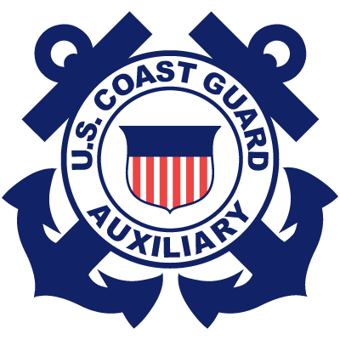D7 FORMAL AWARDS PROCESSING
The award initiator needs to forward a properly formatted draft citation, and a completed and signed CG 1650 form for each award to the next person in their Chain of Leadership. Both documents should be completed in Microsoft Word type. The type font must be Times Roman, in an 11 or 12 point size, and black in color. Signatures on the CG 1650 should be designated by /S/ followed by the originator’s typed full name.
A Meritorious Team Commendation award to more than six members must be accompanied by a separate list of recipients containing the full name, flotilla and EMPLID # of each recommended recipient.
Please ensure that the dates for the period the recipient earned the award are the same on both the CG 1650 form and citation.
Send each award in a separate e-mail for processing. Allow 6-8 weeks for processing.
Following the issuance of an award, its presentation should ordinarily be made by the Commander of the recipient’s flotilla or division.
The process for submitting, reviewing, and obtaining approval for a proposed formal award is as follows: District Awards Coordinator = DAC
Non-staff initiator → FC → DCDR → DCAPT → DAC → DCO → DAC → Sector contact → Presenter
FSO initiator → FC → DCDR → DCAPT → DCOS → DAC → DCO → DAC → Sector contact → Presenter
SO initiator → DCDR → DCAPT → DCOS → DAC → DCO → District Awards Coordinator → Sector contact → Presenter
ADSO initiator → DSO → DDC → DCOS → DAC → DCO → DAC → Sector contact → Presenter
DSO initiator → DDC → DCOS → DAC → DCO → DAC → Sector contact → Presenter
AUXAIR initiator → DSO-AV → DDC-R → DCOS → DAC → DCO → DAC → Air Station
A copy of the DCO-approved award will be sent to the DCDR, DCAPT and ASC when it is forwarded to a Coast Guard Sector or Air Station for processing.
The Sector/Air Station will forward by e-mail a copy of the approved award to DIRAUX for placement in the member’s file. DIRAUX will notify the ADSO-IS (Awards) that the award is ready for AUXDATA input. ADSO-IS (Awards) will input and notify the District Awards Coordinator (DAC) of the input date.
The DAC will forward awards for District Staff members to the Director of Auxiliary for processing, and awards to recognize Auxiliary Aviation activities and members will be processed by Coast Guard Air Stations.

